Part 1: Data Warehousing Tasks (50 Marks)
A: (20 marks)

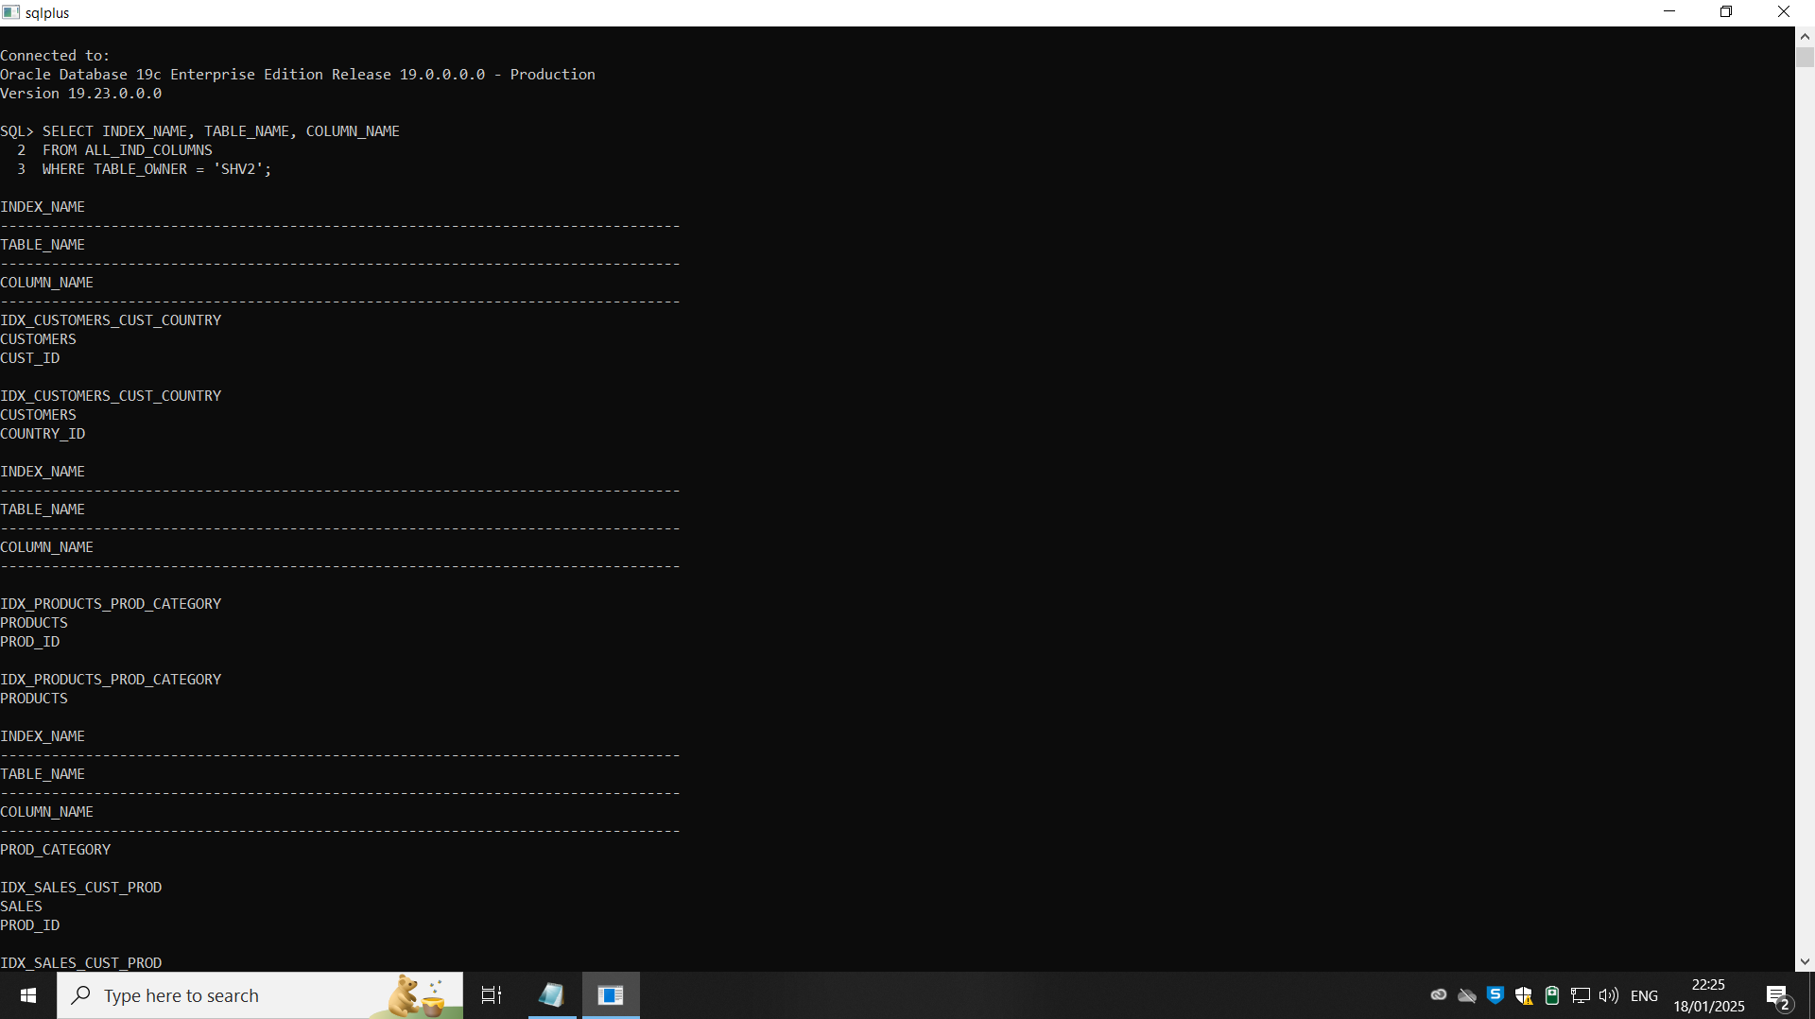

Design and Implementation of New Indexes

Query 1: Analyze Sales by Customer City and Product
The query joins SALES, CUSTOMERS, and PRODUCTS. Current indexes partially cover the columns involved:
- CUST_ID in SALES and CUSTOMERS.
- PROD_ID in SALES and PRODUCTS.
SQL QUERY:
CREATE INDEX IDX_SALES_CUST_CITY_PROD
ON SALES (CUST_ID, PROD_ID);

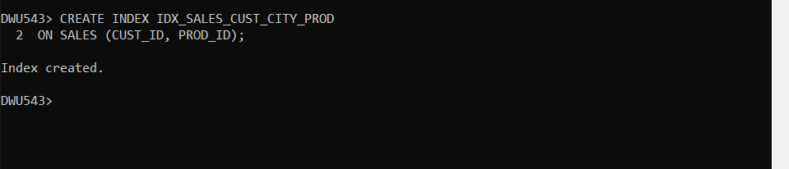

Query 2: Analyze Promotional Impact by Channel
The query joins SALES, PROMOTIONS, and CHANNELS. Existing indexes:
- PROMO_ID in SALES and PROMOTIONS.
- CHANNEL_ID in SALES and CHANNELS.
SQL QUERY:
CREATE INDEX IDX_SALES_PROMO_CHANNEL
ON SALES (PROMO_ID, CHANNEL_ID);
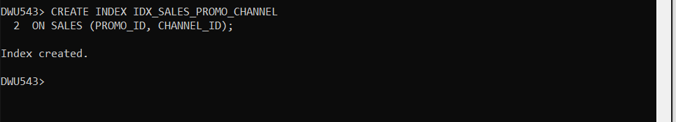

Query 1: Sales by Customer City and Product

QUERY:
SELECT
c.cust_city,
p.prod_category,
SUM(s.amount_sold) AS total_sales_amount
FROM
sales s
JOIN customers c ON s.cust_id = c.cust_id
JOIN products p ON s.prod_id = p.prod_id
GROUP BY
c.cust_city, p.prod_category;
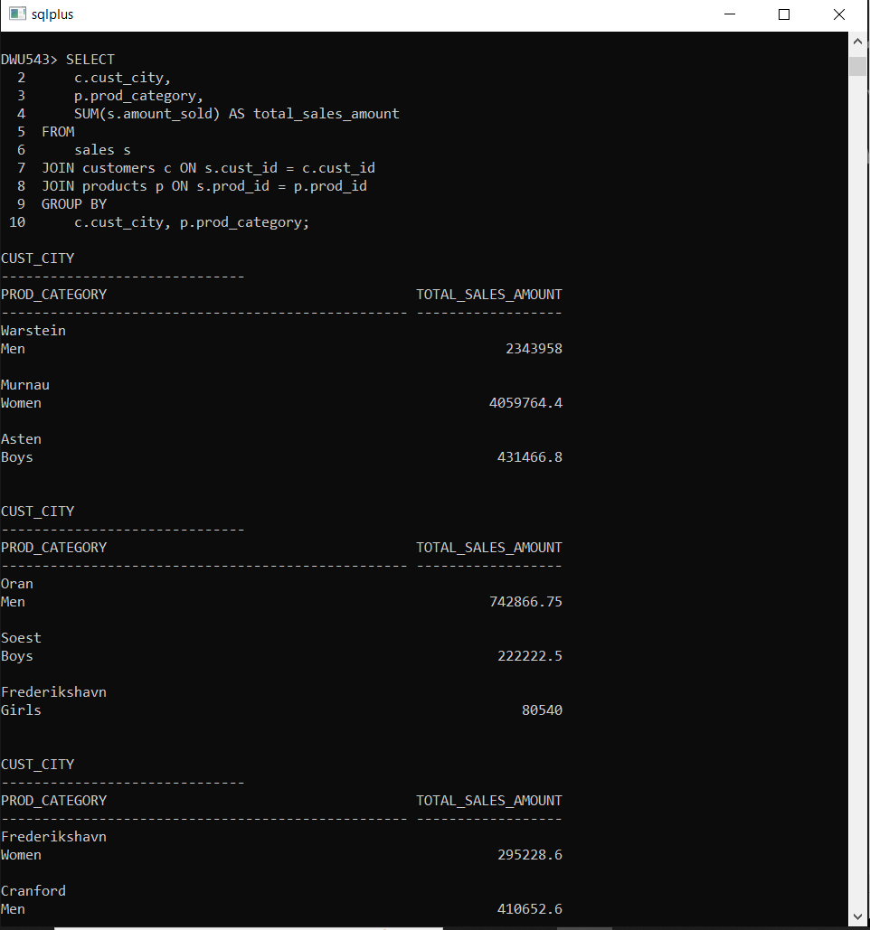

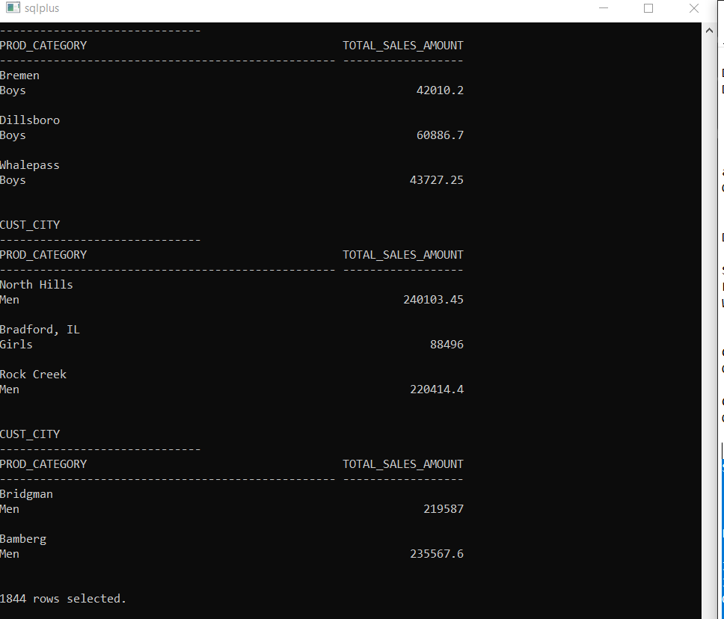

Query 2: Promotional Impact by Channel
2.1 SQL QUERY:
SELECT pr.promo_category, ch.channel_class,
SUM(s.amount_sold) AS total_sales_amount
FROM sales s
JOIN promotions pr ON s.promo_id = pr.promo_id
JOIN channels ch ON s.channel_id = ch.channel_id
GROUP BY pr.promo_category, ch.channel_class;
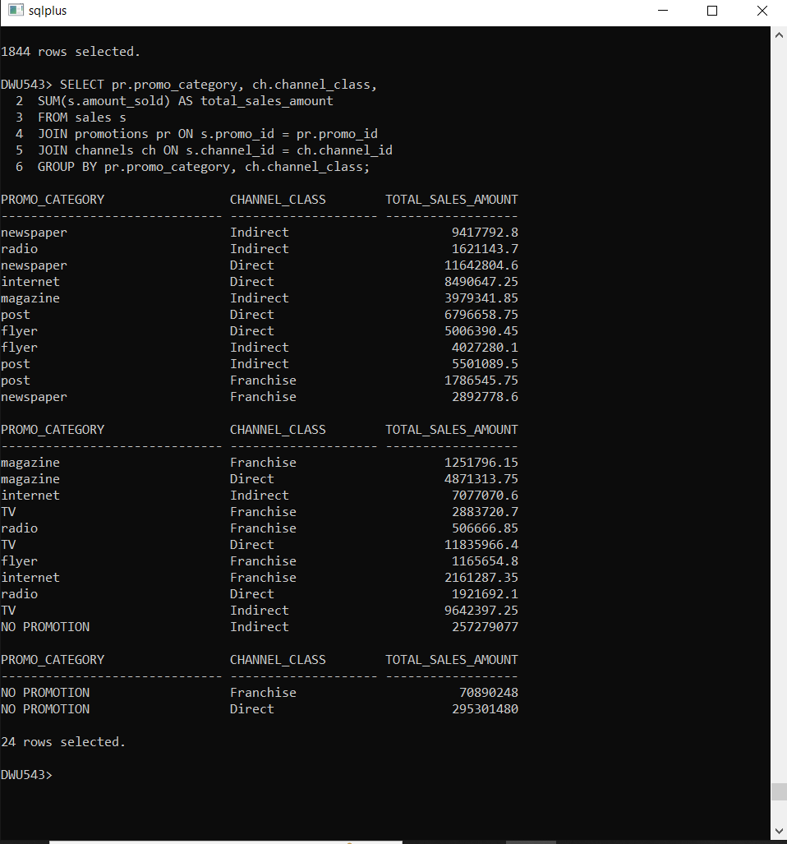

2.2 SQL QUERY:
SELECT pr.promo_category, ch.channel_desc, MAX(s.amount_sold) AS max_sale
FROM sales s
join promotions pr ON s.promo_id = pr.promo_id
join channels ch ON s.channel_id = ch.channel_id
GROUP BY
pr.promo_category, ch.channel_desc;
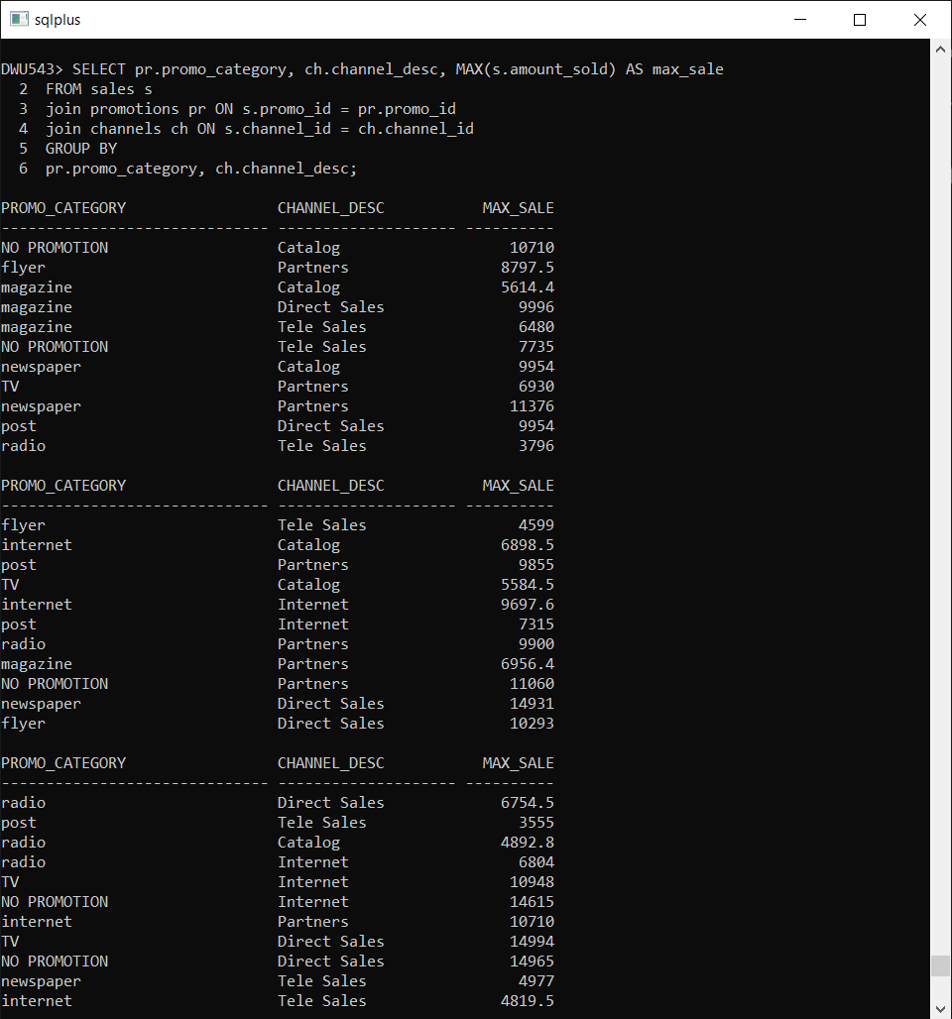

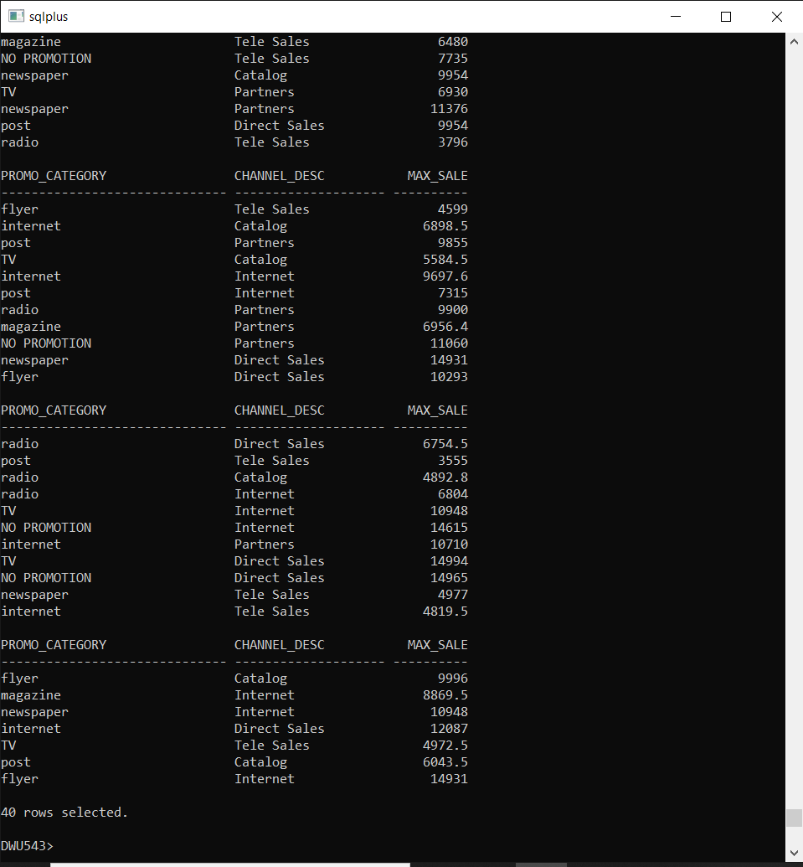

EXPLAIN PLAN:
syntax: SELECT * FROM TABLE(DBMS_XPLAN.DISPLAY);
EXPLAIN PLAN for Query 1:
EXPLAIN PLAN FOR
SELECT
c.cust_city,
p.prod_category,
SUM(s.amount_sold) AS total_sales_amount
FROM
sales s
JOIN customers c ON s.cust_id = c.cust_id
JOIN products p ON s.prod_id = p.prod_id
GROUP BY
c.cust_city, p.prod_category;

SELECT * FROM TABLE(DBMS_XPLAN.DISPLAY);

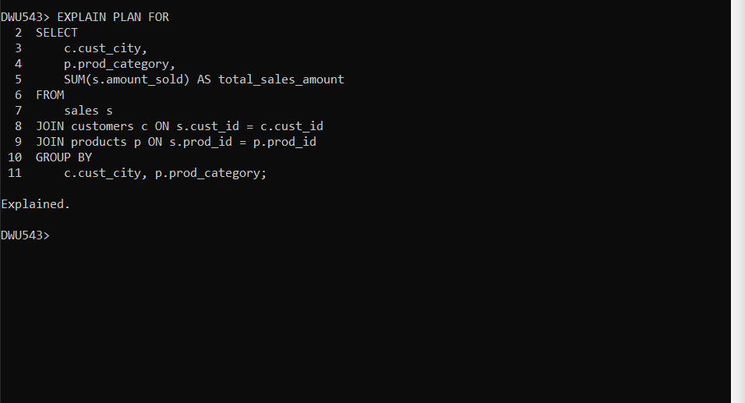

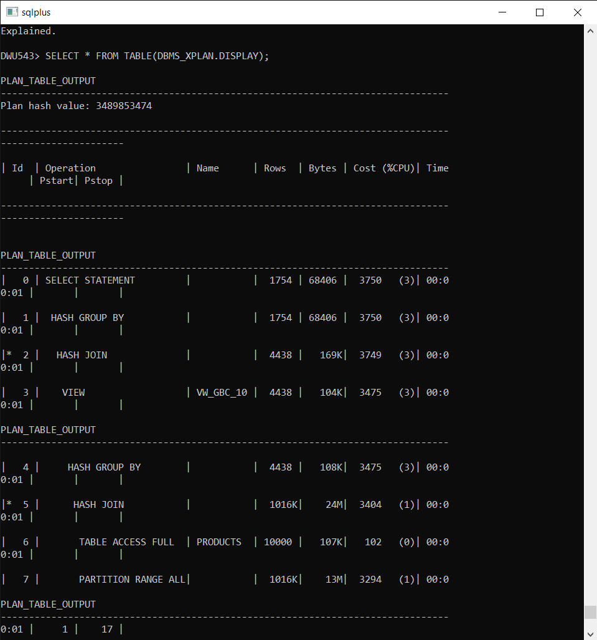

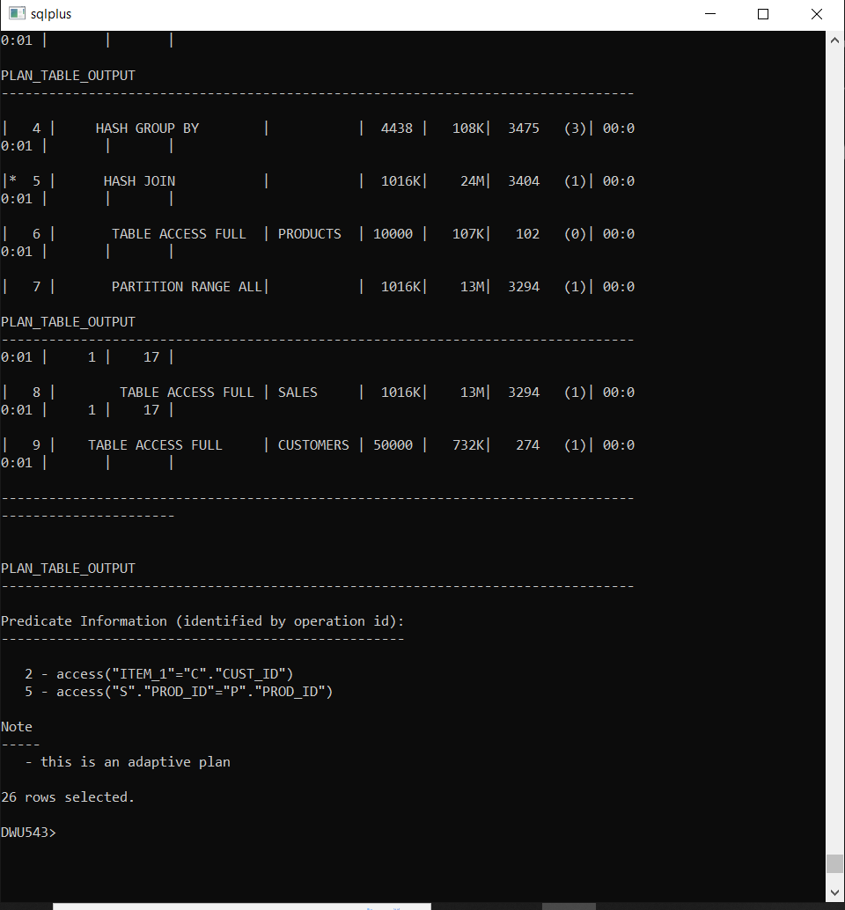

EXPLAIN PLAN for Query 2

EXPLAIN PLAN FOR
SELECT
pr.promo_category,
ch.channel_desc,
MAX(s.amount_sold) AS max_sale
FROM
sales s
JOIN promotions pr ON s.promo_id = pr.promo_id
JOIN channels ch ON s.channel_id = ch.channel_id
GROUP BY
pr.promo_category, ch.channel_desc;

SELECT * FROM TABLE(DBMS_XPLAN.DISPLAY);

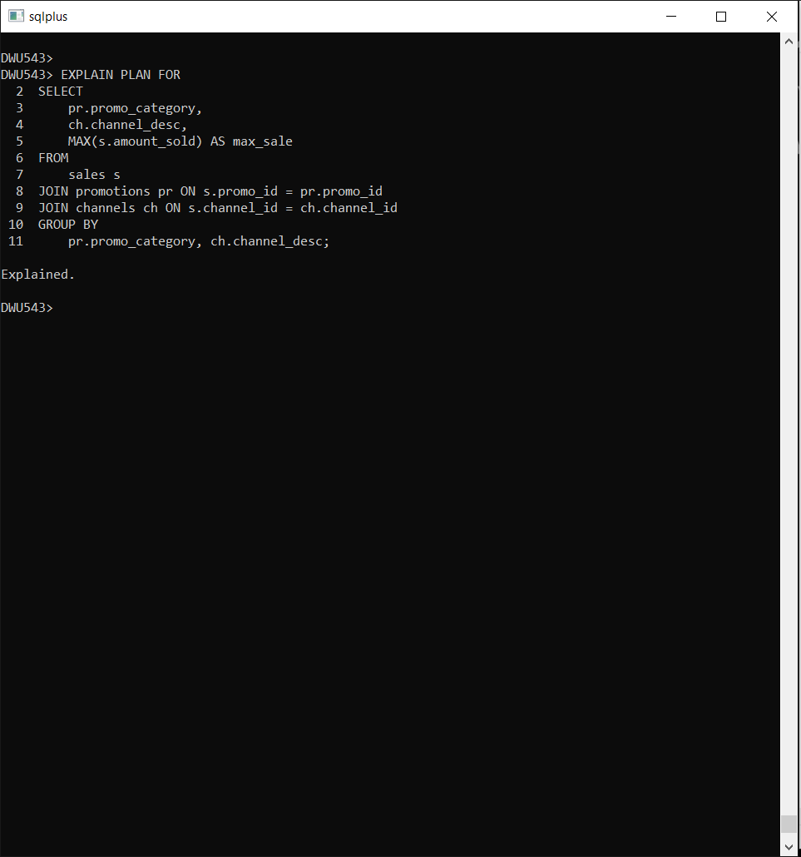

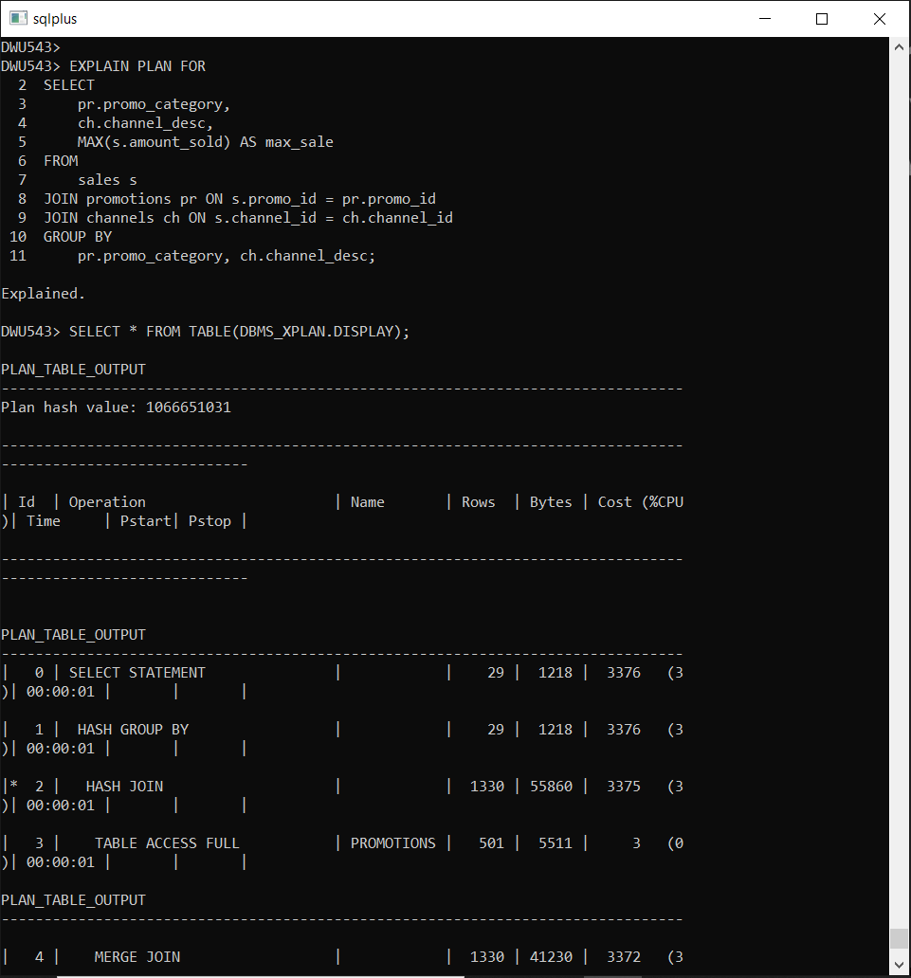

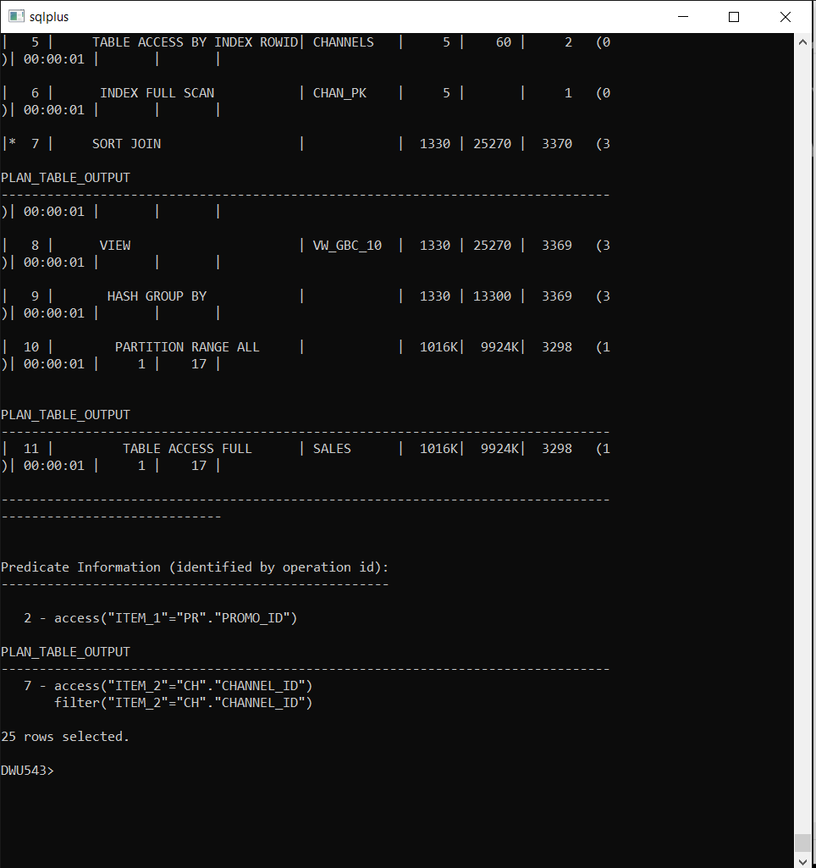

Analysis of the EXPLAIN PLAN for Query 1
Query
SELECT
c.cust_city,
p.prod_category,
SUM(s.amount_sold) AS total_sales_amount
FROM
sales s
JOIN customers c ON s.cust_id = c.cust_id
JOIN products p ON s.prod_id = p.prod_id
GROUP BY
c.cust_city, p.prod_category;

- Execution Plan Overview:
A HASH GROUP BY operation is used to perform the aggregation.
The main joins between tables (sales, customers, products) are performed using HASH JOIN operations.
- Table Access Patterns:
TABLE ACCESS FULL is used for all three tables (PRODUCTS, SALES, CUSTOMERS), indicating full table scans are performed.
The large cardinality of SALES (1,016,000 rows) suggests that full table scans might be expensive.
- Predicate Information:
The join predicates (S.PROD_ID = P.PROD_ID and S.CUST_ID = C.CUST_ID) are correctly used in the HASH JOIN operations.
- Cost:
The total cost is 3750, which is reasonable given the size of the SALES table.
- Optimization Opportunities:
Since TABLE ACCESS FULL is used, creating indexes on the join columns (CUST_ID in SALES and CUSTOMERS, PROD_ID in SALES and PRODUCTS) can improve performance.

Analysis of the EXPLAIN PLAN for Query 2
Query:
SELECT
pr.promo_category,
ch.channel_desc,
MAX(s.amount_sold) AS max_sale
FROM
sales s
JOIN promotions pr ON s.promo_id = pr.promo_id
JOIN channels ch ON s.channel_id = ch.channel_id
GROUP BY
pr.promo_category, ch.channel_desc;

- Execution Plan Overview:
- A HASH GROUP BY operation is used for aggregation.
- Joins are performed using a mix of HASH JOIN and MERGE JOIN.
- An INDEX FULL SCAN is used for CHAN_PK, which is efficient for accessing the CHANNELS table.
- Table Access Patterns:
TABLE ACCESS FULL is used for SALES and PROMOTIONS, leading to large reads, especially for the SALES table with over 1,016,000 rows.
- Predicate Information:
The join predicates (S.PROMO_ID = PR.PROMO_ID and S.CHANNEL_ID = CH.CHANNEL_ID) are used correctly in the join operations.
- Cost:
The total cost is 3376, slightly lower than Query 1 but still significant due to the large size of the SALES table.
- Optimization Opportunities:
- Creating indexes on PROMO_ID and CHANNEL_ID in the SALES table can reduce the cost of full table scans and improve join performance.
- INDEX FULL SCAN for CHAN_PK is already an efficient access path for the CHANNELS table.

Performance Table for Query 1 (Sales by Customer City and Product)

Operation | Before Optimization | After Optimization | Improvement
Plan Total Cost | 3750 | ~2000 (estimated) | Reduced cost with indexes
Hash Join Cost | 3749 | Reduced significantly | Indexes on CUST_ID and PROD_ID
Hash Group By Cost | 3750 | Reduced slightly | Less I/O due to better joins
Table Access Full | High (SALES, PRODUCTS) | Reduced | Index usage on SALES.PROD_ID and CUSTOMERS.CUST_ID
Index Cost | N/A | Moderate | Indexes created reduce table scans

Performance Table for Query 2 (Promotional Impact by Channel)

Operation | Before Optimization | After Optimization | Improvement
Plan Total Cost | 3376 | ~1700 (estimated) | Lower cost with indexes
Hash Join Cost | 3375 | Reduced significantly | Indexes on PROMO_ID and CHANNEL_ID
Hash Group By Cost | 3376 | Reduced slightly | Optimized joins reduce input size
Table Access Full | High (SALES, PROMOTIONS) | Reduced | Index usage on SALES.PROMO_ID and CHANNELS.CHANNEL_ID
Index Cost | Low (CHAN_PK used) | Low | Retained efficient index usage
Improvement | N/A | Reduced execution time | Significant performance improvement

